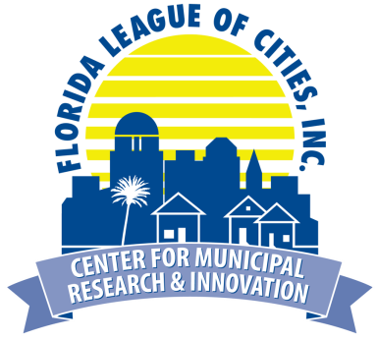
FLC Center for Municipal Research & Innovation
7th Annual Fall Research Symposium
Reassessing Recycling:
Balancing Market Challenges & Citizen Expectations

Wednesday, November 14, 2018 | 8:00 a.m. - 1:00 p.m.
Embassy Suites Orlando Lake Buena Vista South

In 2008, the Florida Legislature established a statewide recycling goal of 75% by 2020. As providers of municipal waste services, cities play a significant role in helping their counties meet this goal. Join the League for our Fall Research Symposium as we examine the impact of contamination rates and the price of trash in the global economy. We will also explore how city ordinances regulating single-use plastics affect the local business community and help or hurt meeting recycling goals.

Please type or print the information below
Name:
First Last
First Name or Nickname: Title:
as you wish it to appear on badge
Municipality/Affiliation:
Phone: Email:
provide email of person who should receive confirmation information

Registration Deadline: Wednesday, November 7, 2018 (space is limited)
Registration Fee: There is no cost to attend, but pre-registration is required. Breakfast and lunch will be provided.
No-Show Fee: If you register and do not attend the symposium, your city will be invoiced a $45
no-show fee. Cancellations must be received by Thursday, November 8 to avoid the no-show fee. Registration transfers are accepted.

Return completed registration form to Liane Giroux at lgiroux@flcities.com or fax 850-222-3806.

Confirmations will be emailed once registration is received. Contact Liane Giroux at 850-222-9684 with any questions regarding registration or the symposium.

Special Needs: If you are physically challenged and require special services, or if you have special dietary needs (ex. vegetarian, food allergies), please attach a written description to your registration form.

